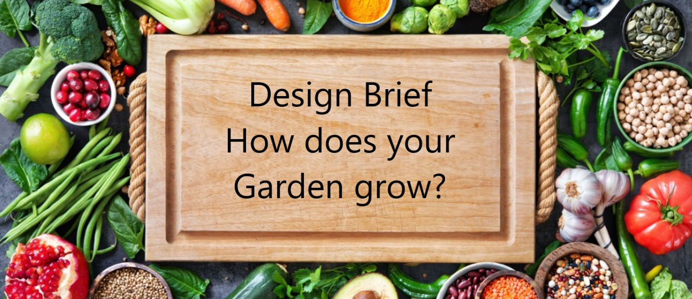

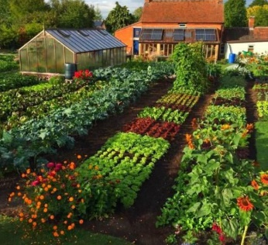

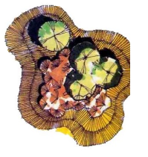Significant change is always occurring globally and locally. Food security is now at the forefront of communities concerns due to transnational restrictions and even interstate travel restrictions. Small scale community farms and produce gardens provide an opportunity to mitigate these issues and provide learning opportunities for communities about growing our own food and sustainable farming practices.

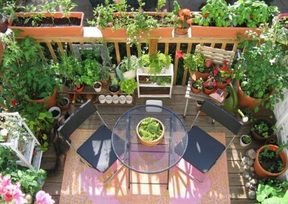

People living in confined spaces, such as appartements, may not have access to their own space for a garden, nor have the knowledge to be able to grow plants, fruits or vegetables. Through a more community-based social environment, we can share this knowledge and learning to provide for ourselves and our community.

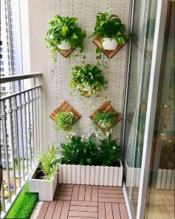

The School Farm is expanding to include additional garden beds to be designed and built, that supports sustainable farming practices. Defined areas or plots will be identified and allocated to groups; however, consideration will be given if an alternate location is requested with suitable reasoning.

How can we improve and add to the productivity of the school farm?

**Project Overview:** Students will work in groups of 3 – 4 to design and build a garden bed, within the school farm. They will be required to research the design and materials to be used for the garden bed, and the plants that are suitable for the environment and conform to the themes in the already established school farm. Students will also be required to document their work as a group and keep a portfolio to show their designs and any changes made to their plans.

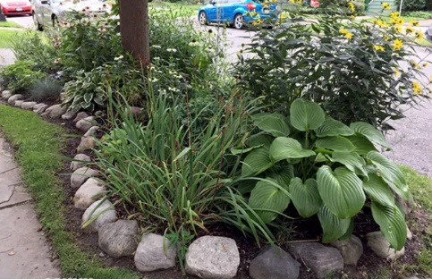

Aim: The aim of this project is to work within a small group to research, design, develop, iterate and build a garden bed within the school farm.

**Presentation:** Through the portfolio, students are to show their research, design ideas and considerations for the construction of the garden bed.

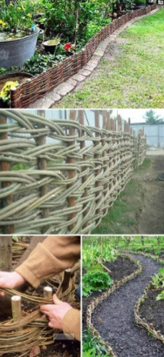

**Key information for the portfolio:**

**Design Description** – a short description of the garden bed you have built, with identification of any key features. This should be no more than three paragraphs or half a page.

**Planning** – How did you plan the project. Include timelines and key points where milestones were met or changes were made. Drawings, sketches, blueprints, etc. will be very useful.

**Production** – How was the garden bed made. What materials were used and why. What difficulties did you encounter and how did you overcome them?

**Evaluation** – What did you learn from the process. How could you have done it better. What mistakes were made, if any, and how did you overcome them.

Resources provided:

Materials for bed walls e.g., wood, metal, etc

Soil

Tools – already located within the school farm.

Fertiliser

Plants – must be requested by XX Xxx 21

Irrigation – will be incorporated within the existing School Farm system

Other resources may be sourced individually or requested through the Teacher